Curriculum Information – Year 6 – Spring Term

Class Texts  English  Reading and Writing | Street Child & Darwin’s Dragons  Revisited genres: Narrative/Settings Description, Diary Entry  New genres: Journalistic Writing, Free verse Poetry  Key objectives:  - drawing inferences such as inferring characters' feelings, thoughts and motives from their actions, and justifying inferences with evidence  - predicting what might happen from details stated and implied  - identifying main ideas drawn from more than 1 paragraph and summarising these  - identifying how language, structure, and presentation contribute to meaning
RE | Our Lady and Saint Benedict Catholic Academy has been chosen to work alongside the Diocese and take part in the Trial of the New RE Curriculum (RED). During this time, we will be working closely with the Diocese to ensure that the New RE Curriculum supports the Teaching and Learning of RE across all Year Groups and is progressive and meets the needs of all learners. The new RE curriculum is entitled 'To Know you More Clearly'. It consists of 6 branches which are spread out over the academic year. Due to the release of the branches the children will be learning about the Liturgical Year out of sequence.
Maths | Decimals:  - Calculate decimal and fraction equivalents e.g. 0.375 and 3/8.  - Identify the value of each digit in numbers given to three decimal places.  - Multiply and divide numbers by 10, 100 and 1000 giving answers up to two decimal places.  - Multiply one digit numbers with up to two decimal places by whole numbers.  - Use written division methods in cases where the answer has up to two decimal places.  - Solve problems involving rounding.  Percentages:  - Compare and order fractions including fractions >1  - Multiply simple pairs of proper fractions, writing the answer in its simplest form.  - Multiply one digit numbers with up to two decimal places by whole numbers.  - Recall and use equivalences between simple fractions, decimals and percentages.  - Solve problems involving the calculation of percentages. E.g. 15% of 360 and use percentages for comparison.  Algebra:  - Use simple formulae  - Generate and describe linear number sequences.  - Express missing number problems algebraically.  - Find pairs of numbers that satisfy an equation with two unknowns.  - Enumerate possibilities of combinations of two variables.  Measure- perimeter, area and volume:  - To recognise that shapes with the same areas can have different perimeters and vice versa.  - Recognise when it is possible to use formulae for area and volume of shapes.  - Calculate the area of parallelograms and triangles.  - Calculate, estimate and compare volume of cubes and cuboids using standard units, including cubic centimetres and cubic metres.  Ratio and proportion:  - Solve problems involving the relative sizes of two quantities where missing values can be found by using integer multiplication and division facts.  - Solve problems involving similar shapes where the scale factor is known or can be found.  - Solve problems involving unequal sharing and grouping using knowledge of fractions and multiples.
Science | Working Scientifically:  - Children will plan and carry out a range of scientific enquiries to develop their working scientifically skills.  - Children will learn how to make scientific predictions, plan and record scientific enquiries and how to write conclusions.  Evolution and Inheritance:  - Children will learn about variation and inheritance and discuss how animals and plants are adapted to their environment.  - We will also consider the ways that adaptation may lead to evolution through our study of The Molliebird by Jules Pottle.  - Through studying the work of Charles Darwin, children will recognise that living things have changed over time and that fossils can provide information about living things that inhabited the Earth millions of years ago.  Animals Including Humans:  - Children will identify and name the main parts of the human circulatory system, and describe the functions of the heart, blood vessels and blood  - We will discuss the impact of diet, exercise, drugs and lifestyle on the way their bodies function and describe the ways in which nutrients and water are transported within animals, including humans. |   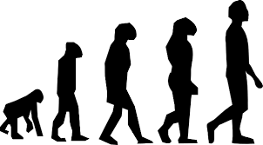  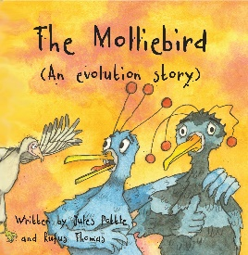  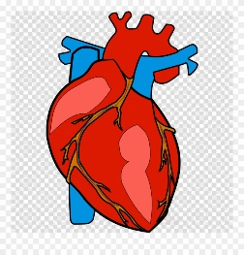
History | Victorians.  - Children will learn who Queen Victoria was and about some of the key events and inventions during her lifetime.  - Children will learn about the changes in industry during the Victorian era that brought people from rural areas into cities during the Industrial Revolution.  - Alongside our study of the novel Street Child by Berlie Doherty in literacy, children will learn about the dirty, crowded conditions many people, including children, had to work in during this time.  - We will also study what was important to Victorians- their culture, religious beliefs and ideas. We will focus on the lives of children and how different children’s lives could be between rich and poor families. | 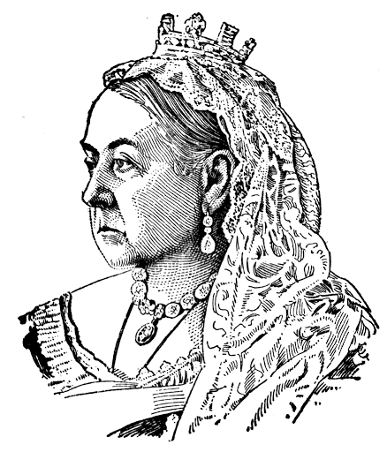
Geography | Earthquakes and Volcanoes:  - Through our study of Earthquakes and Volcanoes children will consolidate their knowledge of map symbols, keys, the compass rose and 4-6 figure grid references.  - Throughout the unit they will use maps and atlases to locate countries and describe features studied.  - They will also describe and understand key aspects of physical geography and human geography of the areas in which earthquakes and volcanoes are present.  - Children will learn how locations around the world are changing and explain some of the reasons for change by studying the causes of earthquakes and volcanic eruptions.  - We will also collect and analyse statistics and other information in order to draw clear conclusions about the areas in which earthquakes and volcanoes occur. | 
Music | Topics of study for Spring 1 and 2 include:  - Creative Composition  - Musical Styles Connect Us  Children will continue to develop their keyboard skills. | 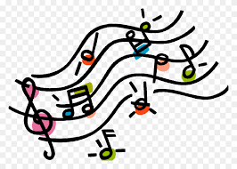
Computing | Data Detectives (continued):  - To find information in databases by filtering and sorting.  - To create graphs from data within a database.  - To be able to find information in linked table databases.  - To be able to find requested information using databases.  Micro:bit  Introduction to Python  - To understand that Python is a text-based coding language and enter simple commands.  - To use Python to perform mathematical calculations.  - To be able to use repetition and Python library functions.  - To understand how Python in Pieces can be used to program a graphical user interface. | 
PE | Dance  In Year 6 the class will continue to learn different dance styles. They will apply this knowledge by creating dance routines independently.  Gymnastics/Parkour In Year 6 children will develop their core strength through their work on apparatus and working with partners. In Gymnastics children will develop their partner balances and incorporate them into routines created independently with large groups.
Art | Artist: Lubaina Himid  - Through the study of artist Lubaina Himid, children will learn how to use multiple layers to create a more complex image.  - Explore how art is used to raise awareness of cultural and social issues.  - Use the sketchbook as a tool to practise, review, adapt and develop a range of ideas.  - Children will create an accurate print design following a given criteria.
Design and Technology | Food & Nutrition  - Children will research ingredients to make a fish curry.  - Children will use ratio and accurate measurements to accurately use ingredients in their correct quantities.  - Children will design a fish curry dish based on their own market research  - Children will develop their cutting and chopping skills including being able to chop vegetables such as carrot, onion, garlic and peppers.  - Children will review their dish upon tasting and sharing feedback with others.
PSHE | Ten:Ten  - Through the RSE 10:10 scheme, children will learn about some of the changes that take place during puberty and emotional changes they will experience.  PSHE  Children will also learn how to stay safe online during safer internet day. | 

