Curriculum Information
Year 5
Spring Term

Class Texts  English  Reading and Writing | This term half term our fiction text is The Indian in the cupboard. We will focus on chapter 15 using the talk for writing approach.  We will also read and enjoy a growing repertoire of texts, both fiction and non-fiction.  The children will…  - Identify how language, structure and presentation contribute to meaning of a text.  - Discuss and evaluate how authors use language, including figurative language, considering the impact on the reader.  - Provide reasoned justifications for views.  - Read and recite age-appropriate poetry which has been learned by heart.  - Make comparisons within and across texts.  - Draw inferences and justify these with evidence from the text e.g. explain how a character’s feelings changed and how they know this; make predictions.  In writing…  - Use the techniques that authors use to create characters, settings and plots.  - We will learn abstract, common, proper, collective and partitive nouns.  - Our verb focus will be regular and irregular verbs and verb phrases.  - Our subject focus will be building single clause sentences, compound and dummy subjects. We will also study gerrunds.  - Choose effective grammar and punctuation  - Ensure correct use of tenses throughout a piece of writing.  - Note, develop and research ideas.  - Plan, draft, write, edit and improve.  - Write sentences that include: relative clauses, modal verbs, relative pronouns, brackets and parenthesis. | 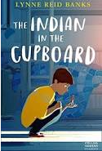    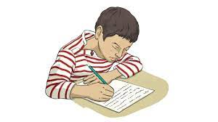
RE | Our Lady and Saint Benedict Catholic Academy has been chosen to work alongside the Diocese and take part in the Trial of the New RE Curriculum (RED). During this time, we will be working closely with the Diocese to ensure that the New RE Curriculum supports the Teaching and Learning of RE across all Year Groups and is progressive and meets the needs of all learners. The new RE curriculum is entitled 'To Know you More Clearly'. It consists of 6 branches which are spread out over the academic year. Due to the release of the branches the children will be learning about the Liturgical Year out of sequence. | 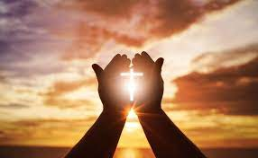
Maths | We will continue to use the Power Maths scheme to support the mastery approach which helps pupils to develop a deep and secure knowledge and understanding of mathematics.  During the term children will…  Multiplication and Division  - Solve problems involving multiplication and division including using their knowledge of factors and multiples, squares and cubes.  - Solve problems involving multiplication and division, including scaling by simple fractions and problems involving simple rates.  - Multiply numbers up to 4 digits by a one- or two-digit number using a formal written method.  - Divide numbers up to 4 digits by a one-digit number using the formal written method of short division and interpret remainders appropriately for the context.  - Solve problems involving division with remainders.  Measure – Area and Perimeter  - Measure and calculate the perimeter of composite rectilinear shapes in centimetres and metres  - Calculate and compare the area of rectangles (including squares), and including using standard units, square centimetres (cm²) and square metres (m²) and estimate the area of irregular shapes.  Fractions  - Compare and order fractions whose denominators are all multiples of the same number.  - Identify, name and write equivalent fractions of a given fraction, represented visually, including tenths and hundredths.  - Recognise mixed numbers and improper fractions and convert from one form to the other and write mathematical statements > 1 as a mixed number.  - Add and subtract fractions with the same denominator and denominators that are multiples of the same number.  - Multiply proper fractions and mixed numbers by whole numbers, supported by materials and diagrams.  Decimals and Percentages  - Read and write decimal numbers as fractions.  - Recognise and use thousandths and relate them to tenths, hundredths and decimal equivalents.  - Round decimals with two decimal places to the nearest whole number and to one decimal place.  - Read, write, order and compare numbers with up to three decimal places.  - Solve problems involving number up to three decimal places.  - Recognise the per cent symbol (%) and understand that per cent relates to ‘number of parts per hundred’, and write percentages as a fraction with denominator 100, and as a decimal.  - Solve problems which require knowing percentage and decimal equivalents of ,1/2,1/4,1/5,2/5,4/5 and those fractions with a denominator of a multiple of 10 or 25.  Graphs and tables  Pupils will :  Solve comparison, sum and difference problems using information presented in a line graph.  Complete, read and interpret information in tables, including timetables. | 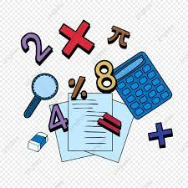  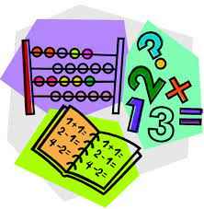
Science | Within science this term we will focus on forces and Earth and Space.  During the term children will…  Working Scientifically  - planning different types of scientific enquiries to answer questions, including recognising and controlling variables where necessary  - using test results to make predictions to set up further comparative and fair tests  - reporting and presenting findings from enquiries, including conclusions, causal relationships and explanations of and a degree of trust in results, in oral and written forms such as displays and other presentations  - identifying scientific evidence that has been used to support or refute ideas or arguments  Science Knowledge….  Earth and Space  - Describe the movement of the Earth and other planets relative to the sun in the solar system.  - Describe the movement of the moon relative to the Earth  - Describe the sun, Earth and moon as approximately spherical bodies.  - Use the idea of the Earth’s rotation to explain day and night and the apparent movement of the sun across the sky  Forces  - Explain that unsupported objects fall towards the Earth because of the force of gravity acting between the Earth and the falling object  - Identify the effects of air resistance, water resistance and friction, that act between moving surfaces  - Recognise that some mechanisms including levers, pulleys and gears allow a smaller force to have a greater effect. |   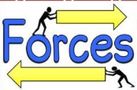  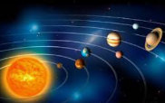
History | This term we will focus on the period of history – The Anglo-Saxons  Children will…  - Use sources of information to form testable hypotheses about the past.  - To describe the main changes in a period of history. Link to religion.  - Refine lines of enquiry as appropriate.  - To describe the characteristic features of the past, including ideas, beliefs, attitudes and experiences of men, women and children.  - To use sources of evidence to deduce information about the past. | 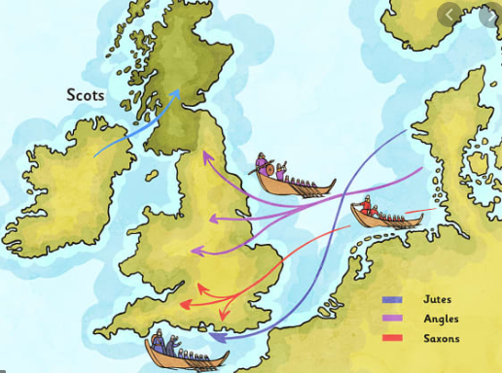
Geography | This term we will focus on North America  Children will…  - Identify and describe the geographical significance of latitude, longitude, Equator, Northern Hemisphere, Southern Hemisphere, the Tropics of Cancer and Capricorn.  - Name and locate the countries of North and South America.  - Create maps of locations identifying patterns (climate zones).  - Name and locate some of the countries and cities of the world and their identifying human and physical characteristics, including hills, mountains, rivers, key topographical features and land-use patterns.  - Use a range of geographical resources to give detailed descriptions and opinions of the characteristic features of a location. | 
Music | In music lessons this term year 5 will focus on composition and chords. They will learn that playing three or more pitches together can create chords in music. Chords provide the basis for accompaniment in music. By using chords in compositions, they can create music that is really interesting. In this unit, they will create an accompaniment and the composition extension activities will help them to learn about chords.  In this unit, we also ask, ‘How Does Music Improve Our World?’. The Social Question evolves as the children move through the scheme while encouraging them to be responsible and kind citizens of the world. | 
Computing | In computing this term we will be focusing on Spreadsheets and Micro Bits. We will use the Purple mash programme to support this.  Spreadsheets  This unit builds on children's existing spreadsheet knowledge and challenges them to apply it in increasingly realistic situations. Through measurement conversions, graphing, weather analysis, budgeting, and planning a holiday, children learn how spreadsheets support real-world decision-making and problem-solving.  Micro Bits  This unit explores the use of the temperature sensor and pins on the micro:bit as well as sensors and inputs covered in the previous year's micro:bits unit. Children will explore the use of variables, If Statements and events in their code to make meaningful projects. |   
PE | During the Spring term Year 5 will be going swimming.  Additionally, we will be learning dance techniques from a specialist dance teacher. | 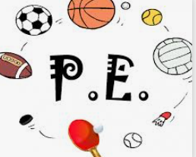
Art | Within Art this term we will be focusing on the work of Van Gogh, we will then practice the skills and apply this to creating their own version of one of his paintings.  Children will…  - know how to organise line, tone, shape & colour to represent forms in movement  - know how to express emotion in art  - Research the work of an artist & use their work to replicate a style  - Use sketchbooks to revisit and review ideas. | 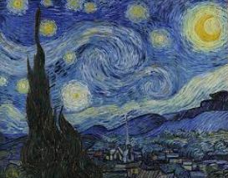
Design and Technology | Our focus for this half term for Design and Technology will be textiles and designing and sewing an Easter decoration.  Children will explain how a product will appeal to a specific audience.  Evaluate appearance and function against original criteria.  Use a range of tools and equipment competently.  Make a prototype before making a final version.  Come up with a range of ideas after collecting information from a range of sources and will produce a detailed step by step plan.
PSHE | Our units of work for this term include mindful movement from our Mind Up curriculum. Pupils will also study personal relationships from our Ten Ten curriculum. Children will learn to identify and understand how to respond to spoken and unspoken pressure, the concept of consent and some practical demonstrations of this and further teaching on how our thoughts and feelings have an impact on how we act. In addition to this, pupils will learn about racial justice linked to racial justice day and ways to keep safe online during safer internet day. |   

