Curriculum Information – Year 4 – Spring Term

English  Class Texts  Reading  Writing  Grammar | King Midas and the Golden Touch  Non-Chronological Report – Greek Mythical Features  Free Verse Poetry  In Year 4 children will understand what they read, in books they can read independently, by  - checking that the text makes sense them  - discussing their understanding and explaining the meaning of words in context  - drawing inferences such as inferring characters’ feelings, thoughts and motives from their actions and justifying their inferences with evidence.  - making predictions based on text and from knowledge of other books  - asking questions to ensure understanding of a text  - identify the main ideas from more than one paragraphs in a text and summarise these  - identifying how language, structure and presentation contribute to meaning  Children in Year 4 will:  - plan their writing using talk for writing to understand and learn from its structure  - compose and rehearse sentences orally  - organise paragraphs around a theme  - use simple organisational devices such as headings and sub-headings  - evaluate and edit their own and others writing  - make improvement by proposing changes to grammar and vocabulary to improve consistency  - proof read their writing for spelling and punctuation errors.  Children will  - Use speech marks accurately to punctuate direct speech  - Use a variety of conjunctions to clarify relationship between ideas (e.g. but, so, when, because, while)  - Appropriate choice of pronoun or noun within a sentence to avoid ambiguity and repetition  - Apostrophes to mark singular and plural possession (e.g. the girl’s name, the boys’ boots)  - Use of commas after fronted adverbials and after subordination (e.g. Later that day,) | 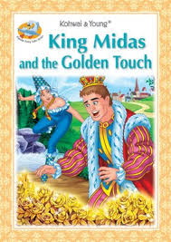
RE | Our Lady and Saint Benedict Catholic Academy has been chosen to work alongside the Diocese and take part in the Trial of the New RE Curriculum (RED). During this time, we will be working closely with the Diocese to ensure that the New RE Curriculum supports the Teaching and Learning of RE across all Year Groups and is progressive and meets the needs of all learners. The new RE curriculum is entitled 'To Know you More Clearly'. It consists of 6 branches which are spread out over the academic year. Due to the release of the branches the children will be learning about the Liturgical Year out of sequence. | 
Maths | Multiplication and division  - solve problems involving multiplication and addition, including using the distributive law to multiply two digit numbers by one digit, integer scaling problems and harder correspondence problems such as n objects are connected to m objects  - multiply two-digit and three-digit numbers by a one-digit number using a formal written layout  - recognise and use factor pairs and commutativity in mental calculations  - use place value, known and derived facts to multiply and divide mentally, including: multiplying by 0 and 1; dividing by 1; multiplying together three numbers  Fractions  - count up and down in hundredths; recognise that hundredths arise when dividing an object by one hundred and dividing tenths by ten  - recognise and show, using diagrams, families of common equivalent fractions  - solve problems involving increasingly harder fractions to calculate quantities, and fractions to divide quantities, including non-unit fractions where the answer is a whole number  Measurement  - find the area of rectilinear shapes by counting squares  - estimate, compare and calculate different measures, including money in pounds and pence.  Decimals  - recognise and write decimal equivalents of any number of tenths or hundredths  - solve simple measure and money problems involving fractions and decimals to two decimal places  - find the effect of dividing a 1- or 2-digit number by 10 and 100, identifying the value of the digits in the answer as ones, tenths and hundredths  - count up and down in hundredths; recognise that hundredths arise when dividing an object by one hundred and dividing tenths by ten | 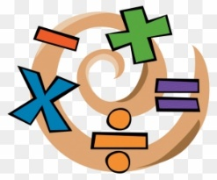
Science | States of Matter  Children will:  - group materials based on their state of matter (solid, liquid, gas)  - know how some materials can change state  - explore how materials change state  - measure the temperature at which materials change state  - know about the water cycle  - know the part played by evaporation and condensation in the water cycle  Sound  Children will:  - know how sound is made  - know how sound travels from a source to our ears.  - know how sounds are made, associating some of them with vibrating  - know the correlation between pitch and the object producing a sound  - know the correlation between the volume of a sound and the strength of the vibrations that produced it  - know what happens to a sound as it travels away from its source. | 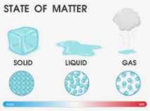  
History | Ancient Greece  The children will:  - know about and talk about the struggle between the Athenians and the Spartans.  - know about some of the things that the Greeks gave the world.  - know that the Greeks were responsible for the birth of the Olympics  - know that the Greeks were an important part of Greek culture | 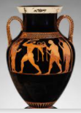
Geography | European Study: Italy  The children will:  - use maps to locate six European countries  - know the countries of the European Union  - know that the UK is no longer part of the European Union  - locate and organise information about a European country  - use maps and locate several European capitals.  - know five differences between living in the UK and a Mediterranean country  - discover Italian culture through food making. | 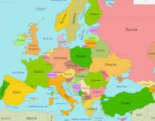  
Music | Children will continue to learn to play the Ukulele | 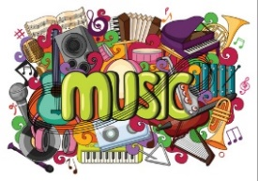
Computing | In computing this term we will learn about the following topics:  Sound Stories  - To understand what makes audiobooks effective and identify the key features that make them engaging.  - To plan and write a script for an engaging audiobook.  - To record clear narration and add sound effects to an audiobook.  - To edit, improve and finalise an audiobook using recording and sound design tools.  Effective Searching  - To understand what a search engine is, how it works and how to use simple keywords to find information online.  - To understand how search engines collect, sort and rank results, and why some results appear first.  - To learn advanced ways to improve searches so we can find the most accurate and useful results quickly.  - To develop strategies to judge whether information online is true and if sources can be trusted.  Lego Coding  In this unit, Year 4 pupils use LEGO SPIKE™ Essential to explore computing through hands-on building and block-based coding. Across four lessons, pupils develop their understanding of algorithms, sequencing, inputs and outputs, and debugging, while solving real-world problems linked to science themes. | 
PE | Dance  Children will:  - begin to develop their understanding of Canon and Unison in dance  - consider their use of space and dance terminology.  Gymnastics/Parkour  Children will:  - continue to develop their ability to express their ideas through movement  - learn to use Unison & Canon whilst working independently in medium sized groups. | 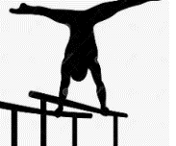
Art | Printing Art – Artist Focus Hokusai.  The children will:  - Will learn about the Artist Hokusai and techniques used.  - They will learn about the history of block printing.  - They will take inspiration from the Great Wave art created by Hokusai to create their own version using the printing techniques. | 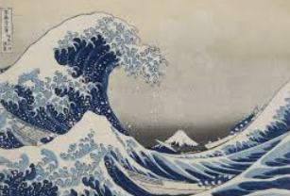
Design and Technology | Textiles – Cross stitch Bookmarks  The children will:  - use ideas from other people when designing  - produce a detailed step by step plan  - suggest alternative plans outlining positive features and drawbacks  - explain how a product will appeal to a specific audience  - evaluate appearance and function against original criteria,  - use a range of tools and equipment competently. | 
PSHE | Children in Year 4 will learn about:  - Life Cycles and Puberty  - Feelings  - Racial Justice.  - Palm Oil – Sustainability  - Children’s mental Health  - Vocations and Careers  - Online safety |   

