Curriculum Information – Year 3 –Spring Term

Class Texts  Guided Reading texts:  English  Reading and Writing | Stone Age Boy  Pupils will be writing -  Recount writing  Non-Chronological Report  Stone Age poetry  ‘Bright Sparks’ - Zoo News, Volcano Alert, When you were my age, King Kafu and the seasons, Can you change the world?, Not a word, When the lights went out.  In Year 3 children will-  draw inferences such as inferring characters' feelings, thoughts and motives from their actions, and justifying inferences with evidence.  predicting what might happen from details stated and implied.  identifying main ideas drawn from more than 1 paragraph and summarising these.  identifying how language, structure, and presentation contribute to meaning. | 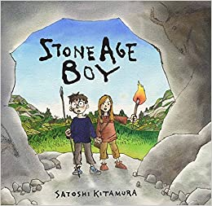
 | Our Lady and Saint Benedict Catholic Academy has been chosen to work alongside the Diocese and take part in the Trial of the New RE Curriculum (RED). During this time, we will be working closely with the Diocese to ensure that the New RE Curriculum supports the Teaching and Learning of RE across all Year Groups and is progressive and meets the needs of all learners. The new RE curriculum is entitled 'To Know you More Clearly'. It consists of 6 branches which are spread out over the academic year. Due to the release of the branches the children will be learning about the Liturgical Year out of sequence. | 
Maths | Multiplication and Division  Pupils will solve problems, including missing number problems, involving multiplication and division, including positive integer scaling problems and correspondence problems in which n objects are connected to m objects.  They will write and calculate mathematical statements for multiplication and division using the multiplication tables that they know, including for two-digit numbers times one-digit numbers, using mental and progressing to formal written methods.  Money  Pupils will record money in £ and pence. They will convert money, add and subtract amounts of money and solve problems that include finding change.  Statistics  Year 3 will present information in different ways including pictograms, bar charts and tables. They will answer questions based on information presented.  Length  Measure length in millimetres, centimetres and metres. They will compare length, add and subtract length and measure the perimeter of shapes. | 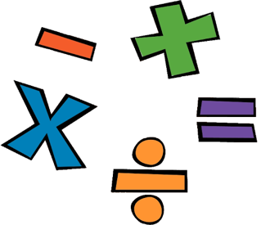  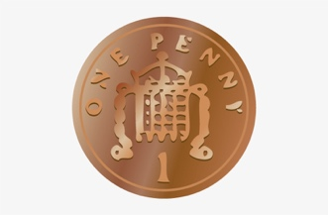
Science | Animals including Humans  We will continue learning –  know about the importance of a nutritious, balanced diet.  know how nutrients, water and oxygen are transported within animals and humans.  know about the skeletal system of a human.  know about the muscular system of a human.  know about the purpose of the skeleton in humans and animals.  Plants  In Year 3 we will learn to  Identify and describe the functions of different parts of the flowering plant: roots, stem/trunk/leaves and flowers  Explore the part flowers play in a flowering plants life cycle, including: pollination, seed formation and seed dispersal  Explain the requirements of plants for life and growth (air, light, water, nutrients from soil, room to grow) and how they vary between plants  Know the way in which water is transported between plants. | 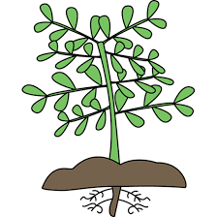
History | Stone Age  Pupils will:  Know about what people learnt from stone aged paintings.  Know about how stone age people hunted for their food and what they ate.  Know about the many differences between the stone, bronze and iron ages.  Know what a typical day would have been like for a stone age man, woman or child,  Know how historic items and artefacts have been used to help build up a picture of life in the past. | 
Geography | Mountains  Pupils will:  Know where the main mountain regions are in the UK.  Know the names of a number of the world’s highest mountains.  Know the names of and locate at least six counties and six cities, in the UK, on a map.  Know the names of four countries from the southern and four from the northern hemisphere. | 
Music | Let your spirit fly  R&B, Western classical, Musicals, Motown, Soul.  Glockenspiel Stage 1  Learning basic instrument skills by playing tunes in varying styles. | 
Computing | Touch Typing  Children will understand the correct way to sit at the keyboard and how to use the home, top and bottom row keys.  Email  Pupils will learn:  to open and respond to an email,  to write an email to someone, using an address book,  to learn how to use email safely and add an attachment to an email. | 
PE | Gymnastics/Parkour  In Year 3 children will learn how to control their bodies and link movements together with fluency. In Gymnastics children will begin to experiment with mirror & match whilst working in pairs. | 
Art | Landscape Paintings  Children will compare landscapes by different artists, paint a background using a wash, use a range of paintbrushes to create effects in a landscape and evaluate how effectively they have reproduced an artist’s landscape. | 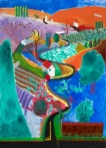
Design and Technology | Textiles  Children will:  sketch a design for a modern pouch,  choose material that is suitable for a pouch,  cut material to the nearest millimetre,  design a pouch that looks attractive,  Select the correct tools to sew a pouch,  and follow a step-by-step plan choosing the correct materials and tools. | 
PSHE | In Year 3 pupils will –  During the Spring term, Year 3 pupils will focus on building positive relationships, understanding forgiveness, staying safe, and developing awareness of mental health and equality. Through the Ten: Ten – Created to Love Others programme, children will explore Jesus’ teachings on forgiveness and reconciliation, learning how relationships can be repaired when things go wrong. They will develop their understanding of different types of relationships, including friendships and family, and discuss what it means to be a good friend.  Children will also learn to recognise bullying, including cyberbullying, and explore strategies to respond safely and seek help. Online safety is a key focus, with pupils learning how to protect personal information and stay safe when using technology. In addition, lessons will support children in identifying early signs of emotional distress in themselves and others, linked to Children’s Mental Health Week.  Towards the end of the term, pupils will explore diversity, fairness, and equality within their community, developing an understanding of racism and the importance of treating everyone with respect. These sessions encourage thoughtful discussion, empathy, and active listening. | 

