Curriculum Information – Year 2 – Spring Term

English  Class Texts  Reading and Writing | Narrative text Alien Landing  Write non chronological reports about the moon landings.  Write poems about space.  In year 2 children will use Talk for Writing to understand Non-Chronological reports, narrative and haiku poems. They will  - Using story maps to internalise texts  - Investigate text to use authorial devices.  - Innovate texts. | 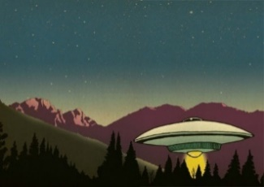  
RE | Our Lady and Saint Benedict Catholic Academy has been chosen to work alongside the Diocese and take part in the Trial of the New RE Curriculum (RED). During this time, we will be working closely with the Diocese to ensure that the New RE Curriculum supports the Teaching and Learning of RE across all Year Groups and is progressive and meets the needs of all learners. The new RE curriculum is entitled 'To Know you More Clearly'. It consists of 6 branches which are spread out over the academic year. Due to the release of the branches the children will be learning about the Liturgical Year out of sequence. | 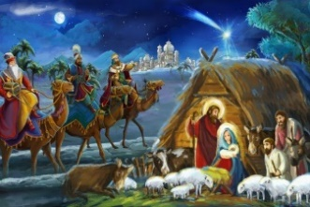  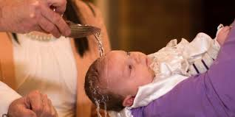  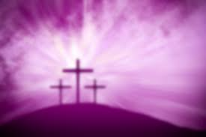
Maths | The children will learn about:  Multiplication and division  Length and Height  Money  Mass and capacity  Temperature | 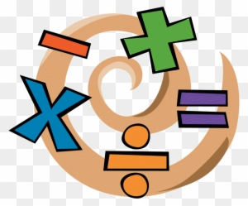
Science | Children in Year 2 will learn:  Spring 1:  - identify and compare the suitability of a variety of everyday materials, including wood, metal, plastic, glass, brick, rock, paper and cardboard for particular uses (2-Everyday materials)  Spring 2:  - find out how the shapes of solid objects made from some materials can be changed by squashing, bending, twisting and stretching. (2-Everyday materials) | 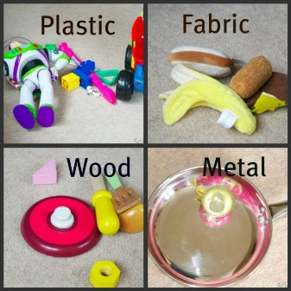
History | Why did man go to the moon?  Children will find out about the life of Neil Armstrong and his mission to the moon. Children will visit Jodrell Bank.  Why is Tim Berners Lee famous?  The children will learn that the world wide web has become a significant part of  Every day modern life. It enables us to share information  quickly and easily, and helps people to communicate and  learn from each other. Like the first printing press, the  world wide web has made the sharing of knowledge  easier. People now have access to information that they  did not have in the past. | 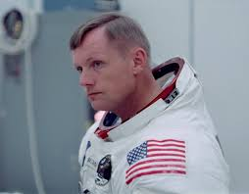  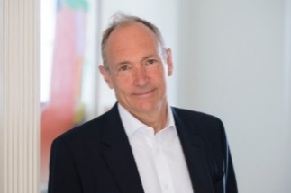
Geography | Australia  Is Australia very different to Abbey Hulton?  The children will learn:  That Australia is a continent and a country in the southern hemisphere. Australia is an island continent surrounded by the Indian Ocean and the Pacific Ocean.  That the country’s interior, which covers two thirds of the country, consists of desert landscape which is referred to as ‘outback.’ Ayers rock, also called Uluru, which is in the centre of the country, is the largest lone standing rock in the world. The Great Barrier Reef.  That the country is divided into six states. Canberra is the capital city. The main cities are all locate at the coast or close to the coast. |   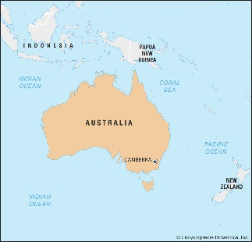
Music | Children will learn:  Inventing a Musical Story - Music is used for many reasons and can help us to tell a story and express our feelings. Music can be loud or soft, fast or slow, smooth and connected, or short and detached. We can also use instruments with different sounds to help communicate a story and different emotions.  Recognising Different Sounds - When voices or instruments work together to play different pitches that sound at the same time, we can hear harmony in music! Explore the voices and instruments used within the music in this unit to identify how and when harmony takes place. | 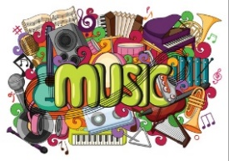
Computing | Children will learn:  Spreadsheets  Questioning  How to be safe online | 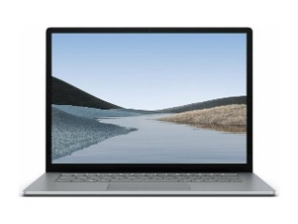
PE | FUNdamentals of movement  Children will become increasingly competent in the FUNdamentals of movement (Agulity, Balance, Co-ordination) and will apply these skills in a variety of sports and activities  Gymnastics - children will also begin to refine movements into actions showing control, extension and a degree of fluency. They will use these movements when creating routines with guidance | 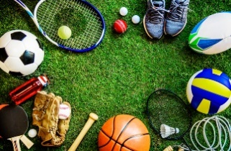
Art | How do artists create so many different colours?  The children will:  Know about the work of Clifford Possum Tjapaltjarri.  Know how to create brown with paint.  Know how to create tints with paint by adding white.  Know how to create tones with paint by adding black.  Know how to mix paint to create all the secondary colours.  Suggest how artists have used colour, pattern and shape. | 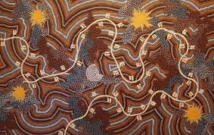
Design and Technology | How do vehicles move?  Children will design a wheeled vehicle.  Explore wheels and axles.  Create products using wheels & axles
PSHE | Children in Year 2 will learn about:  Mindful movement  I am unique  Girls and Boys  Clean and Healthy  Sharpening senses  Safer Internet Day  Racial justice Day  Perspective Taking  Choosing Optimism  Likes and Dislikes  Feelings Inside and Out  Super Susie gets angry | 

