Curriculum Information: Year 1 Spring Term

English  Class Texts  Reading and Writing | Katie in London  Narrative: - Katie in London  Non-fiction: Great Fire of London  Poetry: Shape Poem / Calligrams  In Year 1 children will understand what they read, in books they can read independently, by  - Discussing the main events of the story.  - Discussing the characters in the story.  - Discussing the words that the author has used.  In year 1 children will use Talk for Writing to immerse themselves in a class text by  - Using story maps to internalise texts,  - Take part in drama to help them to understand texts  - Investigate text to use authorial devices.  - Retelling and innovating texts. | 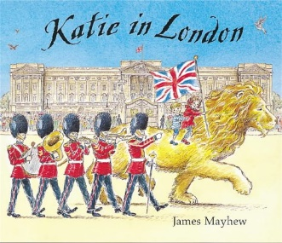
RE | Our Lady and Saint Benedict Catholic Academy has been chosen to work alongside the Diocese and take part in the Trial of the New RE Curriculum (RED). During this time, we will be working closely with the Diocese to ensure that the New RE Curriculum supports the Teaching and Learning of RE across all Year Groups and is progressive and meets the needs of all learners. The new RE curriculum is entitled 'To Know you More Clearly'. It consists of 6 branches which are spread out over the academic year. Due to the release of the branches the children will be learning about the Liturgical Year out of sequence. | 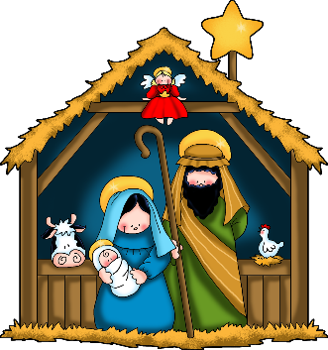  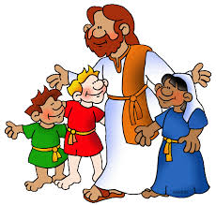  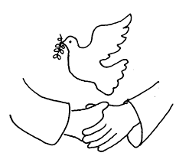  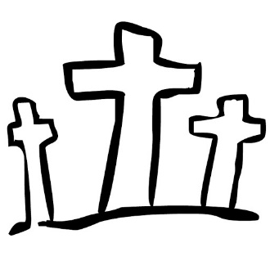
Maths | Number and Place Value  - Children will learn to count to and across 100, forwards and backwards, beginning with 0 or 1, or from any given number.  - They will learn to count, read and write numbers to 10 in numerals.  - They will learn to count in multiples of 2s, 5s and 10s.  - They will learn how to identify 1 more and 1 less in any given number.  - They will be able to identify and represent numbers using objects and pictorial representations including the number line, and use the language of: equal to, more than, less than (fewer), most, least  - They will be able read and write numbers from 1 to 20 in numerals and words  Addition and Subtraction  - Children will learn how to read, write and interpret mathematical statements involving addition (+), subtraction (−) and equals (=) signs  - They will be able to represent and use number bonds and related subtraction facts within 20  - They will add and subtract one-digit and two-digit numbers to 20, including 0  - They will be able to solve one-step problems that involve addition and subtraction, using concrete objects and pictorial representations, and missing number problems such as 7 = ? − 9  Measurement  Children will learn to compare, describe, and solve practical problems for:  - lengths and heights  - mass/weight  - capacity and volume  - time  Children will learn how to measure and begin to record the following:  - lengths and heights  - mass/weight  - capacity and volume  - time (hours, minutes, seconds)  - They will recognise and know the value of different denominations of coins and notes.  - They will sequence events in chronological order using language.  - They will recognise and use language relating to dates, including days of the week, weeks,  - months and years  - They will learn how to tell the time to the hour and half past the hour and draw the hands on a clock face to  - show these times. | 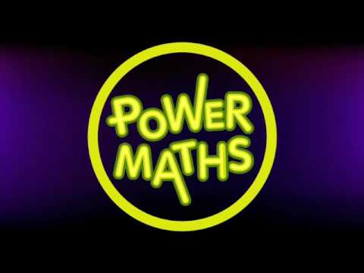
Science | Materials  Children in Year 1 will learn to:  - Distinguish between an object and the material from which it is made.  - Identify and name a variety of everyday materials, including wood, plastic, glass, metal, water, and rock.  - Describe the simple physical properties of a variety of everyday materials.  - Compare and group together a variety of everyday materials on the basis of their simple physical properties.  Plants  Children in Year 1 will learn to:  - Identify and name a variety of common wild and garden plants, including deciduous and evergreen trees.  - Identify and describe the basic structure of a variety of common flowering plants, including trees | 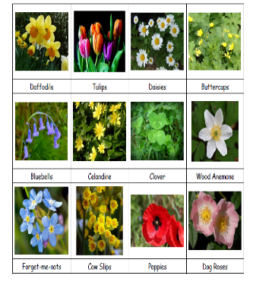  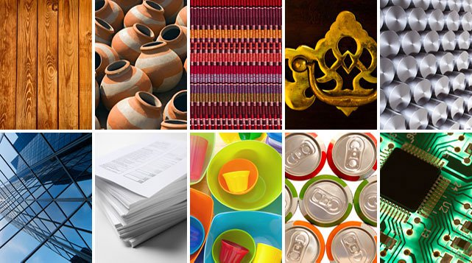
History | Why did London burn?  Children will learn to:  - Know a famous person from the past and explain why they are famous.  - Know what a number of older objects were used for.  - Spot old and new things in pictures.  - Know words and phrases like before after past present then and now.  - Know about many of the changes that have happened since I was born. | 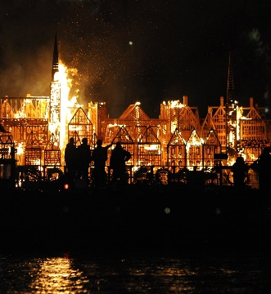
Geography | Geography: How Is Abbey Hulton different to London?  Children will learn to:  - Know the names of the four countries that make up the UK and name the three main seas that surround the UK.  - Know the main differences between a city, town and village.  - Identify the capital cities on a UK map.  - Know some famous landmarks from London.  - To understand what a journey line is.  - To know the difference between ariel view and street view on an interactive map. | 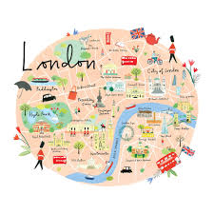  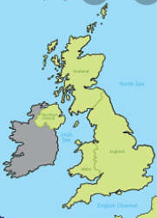
Music | The children will learn:  Exploring sounds:  If you’re happy and you know it, Sing me a song, Sparkle, Rhythm in the way we walk, Big bear funk.  Learning to Listen:  Days of the week, Name song, Cuckoo, Upside down, Hush little baby |   
Computing | Purple Mash  Maze Explorer  In this unit the children will learn:  - To understand the functionality of the basic direction keys.  - To understand how to create and debug a set of instructions.  - To understand how to change and extend the algorithm list.  Animated storybooks  In this unit the children will learn:  - To create an animated e story.  - To add sound to a story, including voice recording and music.  - To work on a more complex story, including adding backgrounds and copying and pasting pages. | 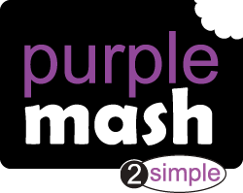
PE | Gymnastics  In gymnastics the children will learn:  - How to develop pupil’s ability to mount/dismount apparatus safely.  - How to develop pupil’s ability to hold their own body weight.  - Children will begin to refine movements into actions showing control, extension and a degree of fluency.  Dance  In dance the children will learn:  - Children will start to explore how change their dance moves with relation to a stimulus (Happy/Sad, Fast/Slow) | 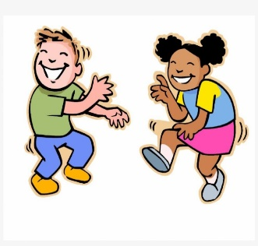  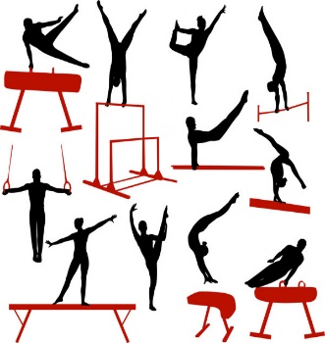
Art | Painting  Children in Year 1 will learn:  - The names of the primary and secondary colours.  - How to create a repeating pattern in print.  - Describe what can be seen and give an opinion about the work of an artist. | 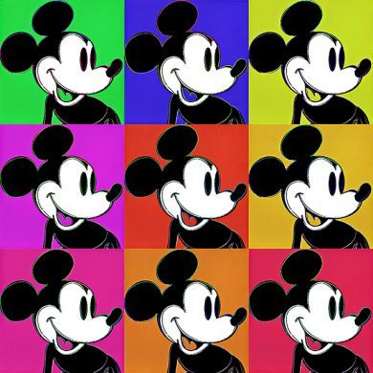  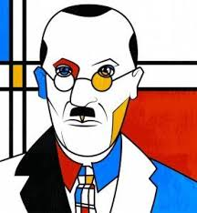
Design and Technology | Mechanical Systems  The children will learn how to:  - To design products that have a clear purpose and an intended user.  - Tell someone about their idea  - To create a design plan.  - Use material to practise screwing and gluing materials to make and strengthen products.  - Build structures, exploring how they can be made stronger, stiffer and more stable.  - To use a product using levers and sliders. | 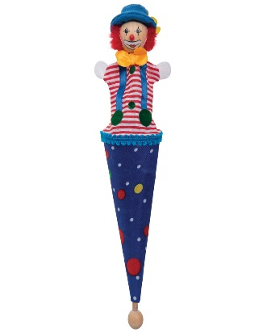
PSHE | Children’s mental health  Racial justice day  Vocations: Careers and aspirations  Online safety: My personal information  Great British Spring Clean: Recycling Day  Ten Ten  Special people  Treat others well  And say sorry  Good secrets and bad secrets  Physical contact  Harmful substances |   

