Curriculum Information – Reception – Spring Term

Class Texts  English  Reading and Writing | Dinosaurs and Beasts  This term, our literacy lessons are based on our topic, Dinosaurs and Beasts. Using Talk for Writing, we will read and explore the following books, as well as additional texts to support changing seasons and our understanding of the world:  Dinosaur Roar!  Dinosaurs and All That Rubbish  Tyrannosaurus Drip  Where The Wild Things Are  The Bog Baby  Not Now Bernard  In reception, we will grow our love of reading by:  - Participating in whole class guided reading sessions  - Providing opportunities for children to role play stories through small world, character masks and adult-led activities  - Discussing and questioning fiction and non-fiction texts that we have read  In writing, children will:  - Implement letters taught in phonics  - Use their knowledge of Talk for Writing to retell familiar stories.  - Use drama and resources to act out stories  - Use story maps and texts to write for a range of purposes including descriptions, non-fiction and posters. | 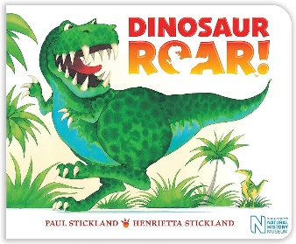  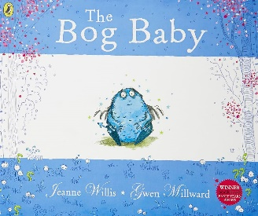
RE | Our Lady and Saint Benedict Catholic Academy has been chosen to work alongside the Diocese and take part in the Trial of the New RE Curriculum (RED). During this time, we will be working closely with the Diocese to ensure that the New RE Curriculum supports the Teaching and Learning of RE across all Year Groups and is progressive and meets the needs of all learners. The new RE curriculum is entitled 'To Know you More Clearly'. It consists of 6 branches which are spread out over the academic year. | 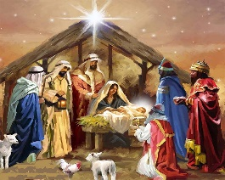
Maths | Numbers to 10  - Recognise the numerals 6, 7, 8, 9, and 5  - Count to 10  - Represent numbers using concrete and pictorial representations  - Use a ten frame and counters are used  - Explore number bonds  Comparing numbers within 10  - Identify more or less than a number up to 10  - Begin to understand that addition combines two groups of objects  - Begin to understand that subtraction is the difference between two amounts.  Addition to 10  - Use the part-whole model to introduce the concept of addition as the combining of two parts into a whole  - Use the vocabulary of ‘altogether’  Measure  - Use the language of length, height and weight  - Learn how to compare two or more items using the vocabulary of measure  - Begin to use non-standard measures to measure then compare items  Number bonds to 10  - Continue to explore addition, looking specifically at the number bonds to 10.  - Show addition by using a ten frame and whole-part model, which have both been used before.  - Children begin to explore the bonds in a more systematic way  - Recognise the commutative law of addition, that no matter the order of the addition, it will still produce the same answer  - Children are introduced to missing parts as an introduction to subtraction by counting on or back  Subtraction  - Continue to explore subtraction, looking specifically at the number bonds to 10  - Show number bonds using counters and the part-whole model, which have both been used before  - Children will begin to work with subtraction number bonds, following the ‘missing part’ structure.  Exploring patterns  - Begin to recognise, extend, create and explain simple repeating patterns  - Consider patterns not just in pictures but in their everyday environment and using sounds, words and actions
Understanding the world | The Natural World - Science  In order to explore the Natural World, children will have a wide range of experiences, especially utilising the great outdoors, to develop their understanding of their environment and changes that occur. This term we will be looking at:  - Senses – taste and smell linked to Chinese New Year food tasting  - Experimenting with changes - volcanoes/dinosaur eggs  - Seasons - Spring  People and Communities - Geography  Children will know and understand that there are a range of communities that celebrate different events. We will discover and celebrate different cultures within our society and beyond. This term we will be learning about:  - China and Chinese New Year  - Pangea – What the world used to look like  Past and Present - History  Children will discover and understand history of key people, including saints. We will also explore fossils and key historical events This will provide children with the opportunity to consider how the world has changed over time and the events that have helped to shape the world that we know today. We will explore:  - St George  - St Patrick  - Pancake day/Shrove Tuesday  - Dinosaurs – Fossils  - Pompeii
Physical Development | Throughout the day, we work on a range of activities to encourage and strengthen physical development, some of which include:  - Dough disco  - Pencil control and letter formation  - Climbing and balancing  - Dancing  - Fine and gross motor activities  - Targeted outdoor and indoor activities
PE | We will continue to work on the FUNdamentals of movement through our PE lessons. | 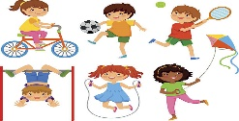
Expressive Arts and Design | We will be using a range of different skills including observation, positional language, experimentation and prior knowledge to represent ideas in different formats.  - Shading  - Acting out from story mapping  - Printing & rubbings  We will also develop our abilities to keep in time to a beat and hear the pulse in music. | 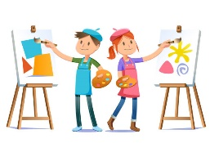
PSHE | In reception pupils will learn:  - Religious understanding – understanding why the Bible is so special and know that Jesus loves us, teaching us to love one another.  - Personal relationships – naming different family and friend relationships, understanding positive and negative behaviour and to learn how to look to Jesus as a role model.  - Mind Up – Mindful seeing | 

