Dear Parent/Carer,

Our school is part of Operation Encompass which is a national scheme that operates jointly between schools and police forces. Operation Encompass is the reporting to schools, prior to the start of the next school day, when a child or young person has experienced domestic abuse. As a school setting we have ensured that a member of our staff, (Designated Safeguarding Lead and Deputy Designated Safeguarding Lead) known as Key Adults, have been trained in the Operation Encompass procedures allowing us to then use the information that has been shared, in confidence, to support the child/ren in our care.

The Domestic Abuse Act 2021 identifies children who experience domestic abuse as victims of domestic abuse in their own right. On 24 May 2024 Royal Assent was granted to The Victims and Prisoners Act. The Act placed Operation Encompass into Law. This places a statutory obligation on police forces to share Operation Encompass notifications with schools/educational settings. We are keen to offer the best support possible to all our pupils and through Operation Encompass we will be able to provide the best possible support to our children.

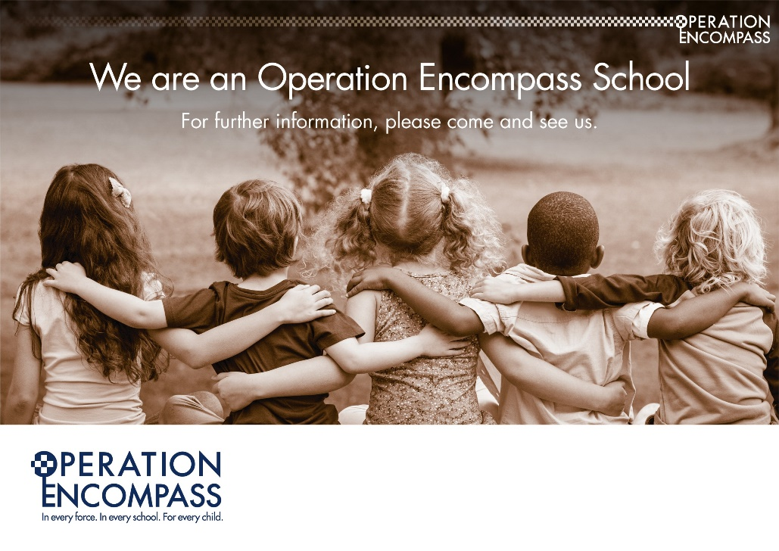
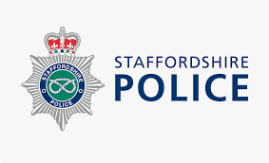

With thanks,
Mrs Sarah Clowes Principal

​​​

Our Lady and St Benedict Catholic Academy, Abbey Lane, Abbey Hulton, Stoke- on- Trent. ST2 8AU
Telephone: 01782 234646 E-mail: office@olsbprimary.org.uk
We are proud to be a part of St Gabriel the Archangel Catholic Multi-Academy Trust which is a company limited by guarantee registered in England & Wales with company number 08146661.
Registered office address: c/o Painsley Catholic College, Station Road, Cheadle, Staffordshire ST10 1LH

