Curriculum Information – Year 6 – Summer Term

Class Texts  English  Reading | The Lion, the Witch and the Wardrobe by CS Lewis  Key objectives:  - Retrieving facts from the text and selecting evidence  - drawing inferences such as inferring characters' feelings, thoughts and motives from their actions, and justifying inferences with evidence  - predicting what might happen from details stated and implied  - identifying main ideas drawn from more than 1 paragraph and summarising these  identifying how language, structure, and presentation contribute to meaning | 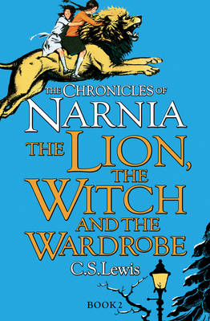
Writing | New genres: Narrative and Persuasive writing.
Maths | Statistics  This unit builds on the skills children have gained in Year  5 interpreting and using line graphs. They learn what  the mathematic mean is and how to calculate it and are  introduced to pie charts.  Sats Prep  Children will continue to work on past papers and targeted questions to prepare themselves for the end of KS2 tests.  Problem Solving  The unit builds on children’s work in previous units. Children  apply their knowledge and skills in problems with and  without context, some of which may appear less familiar  because the problem is non-routine. They represent problems using bar models to help make sense of a problem and the relationships within it, exposing the operations needed.
Science | Working Scientifically:  - Children will plan and carry out a range of scientific enquiries to develop their working scientifically skills.  - Children will learn how to make scientific predictions, plan and record scientific enquiries and how to write conclusions.  Animals Including Humans (continued from Spring 2):  - Children will identify and name the main parts of the human circulatory system, and describe the functions of the heart, blood vessels and blood  - We will discuss the impact of diet, exercise, drugs and lifestyle on the way their bodies function and describe the ways in which nutrients and water are transported within animals, including humans.  Living Things and their Habitats:  - describe how living things are classified into broad groups according to common observable characteristics and based on similarities and differences, including microorganisms, plants and animals  - give reasons for classifying plants and animals based on specific characteristics |   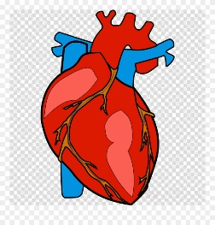  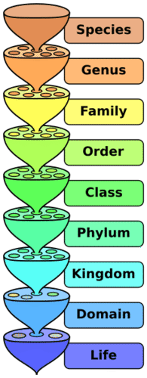
History | World War 2  - Children will compare and contrast the events of ww2 with ww1.  - We will focus on the evacuation of children during ww2 and the Blitz.  Early Islamic Civilisation:  - Children will learn about a Non-European society and compare to British History – Early Islamic Civilisation  - Children will learn that many of the early civilisations gave much to the world and learn how to place features of historical events and people from the past societies and periods in a chronological framework.  - Children will research in order to find similarities and difference between two or more periods of History | 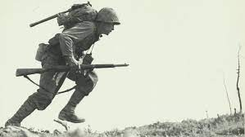  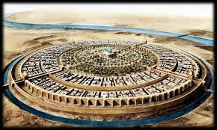
Geography | Economic Activity:  - Children will learn, through case studies of the UK and abroad, why industrial areas and ports are important.  - They will know main human and physical differences between developed and third world countries.  - Children will learn how jobs may be different in other locations.  - Children will learn about time zones and work out differences. | 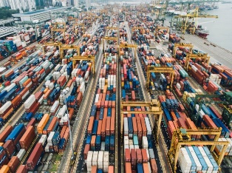
Music | - Improvising with confidence  - Farewell Tour | 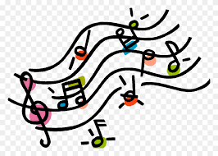
Computing | Spreadsheets (Google Sheets)  - Children will understand what a Google Sheet spreadsheet looks like and be able to navigate this.  - Children recognise how using formulae allows the data to change and the calculations to update automatically.  - Children will use excel to represent data and then finally plan a cake sale with a budget.  3-D Moddelling  - • To explore and develop simple 3D models using CAD software.  - To explore the effect of moving points when designing.  - To plan, design and begin creating packaging to meet a design brief.  - To refine, assemble and evaluate the finished packaging prototype.  Micro:bit transition to high school  Using the micro:bit and Make Code environment, this transition project aims to support students moving from Key Stage 2 to Key Stage 3, facilitating a smooth progression between primary and secondary computing education. This unit ensures curriculum continuity by aligning teaching approaches and learning objectives between the two stages, whilst also familiarising students with the new school environment, teachers, and classmates. Additionally, it challenges students academically, which subsequently prepares them for the challenges of KS3, allowing them to adjust gradually and build confidence. | 
PE | Strike & Field Games (Cricket):  - children will continue to refine activity specific skills and activity specific tactics. They will be able to use the knowledge gained to make tactical decisions independently and explain why they have selected these tactics.  Athletics:  - Children will further develop athletics skills focussing on hurdles, sprinting, triple jump, javelin and shotput. | 
Art | Linked to local Art: Pottery  - Art this term will be linked to the local area and influenced by this. Children will be carrying out relief printing and form this onto a clay tile using the influences and ideas from Stoke-On-Trent.  - Children will investigate a range of clay skills during this term which include: joining, tooth, fettling, priming, fixing and finally sealing.
Design and Technology | Bird Boxes  - Children will understand and learn about joints and connecting pieces of wood.  - Children will learn about their local environment and the importance of looking after it.  - Children will also apply their knowledge of circuits and gears and pulleys to design a tool to hoist the bird box into position.
PSHE  RHE | - Through Mind up children will deepen their understanding of being mindful in the world.  - Through the RSE 10:10 scheme, children will learn about some of the changes that take place during puberty. |   

