Curriculum Information – Year 5 – Summer Term

English  Class Texts  Reading  Writing | Narrative - Beowulf  Poetry – Senryus Poems  Play script -The Tempest  Persuasive Advert - Vikings  In Reading Children will:  - Read and enjoy a growing repertoire of texts, both fiction and non-fiction  - Identify how language, structure and presentation contribute to meaning of a text  - Discuss and evaluate how authors use language, including figurative language, considering the impact on the reader  - Provide reasoned justifications for views  - Read and recite age-appropriate poetry which has been learned by heart  - Make comparisons within and across texts  - Draw inferences and justify these with evidence from the text e.g. explain how a character’s feelings changed and how they know this; make predictions  In writing children will:  - Use the techniques that authors use to create characters, settings and plots  - Guide the reader by using a range of organisational devices, including a range of connectives  - Choose effective grammar and punctuation  - Ensure correct use of tenses throughout a piece of writing  - Note, develop and research ideas  - Plan, draft, write, edit and improve  - Write sentences that include: relative clauses, modal verbs, relative pronouns, brackets and parenthesis. | 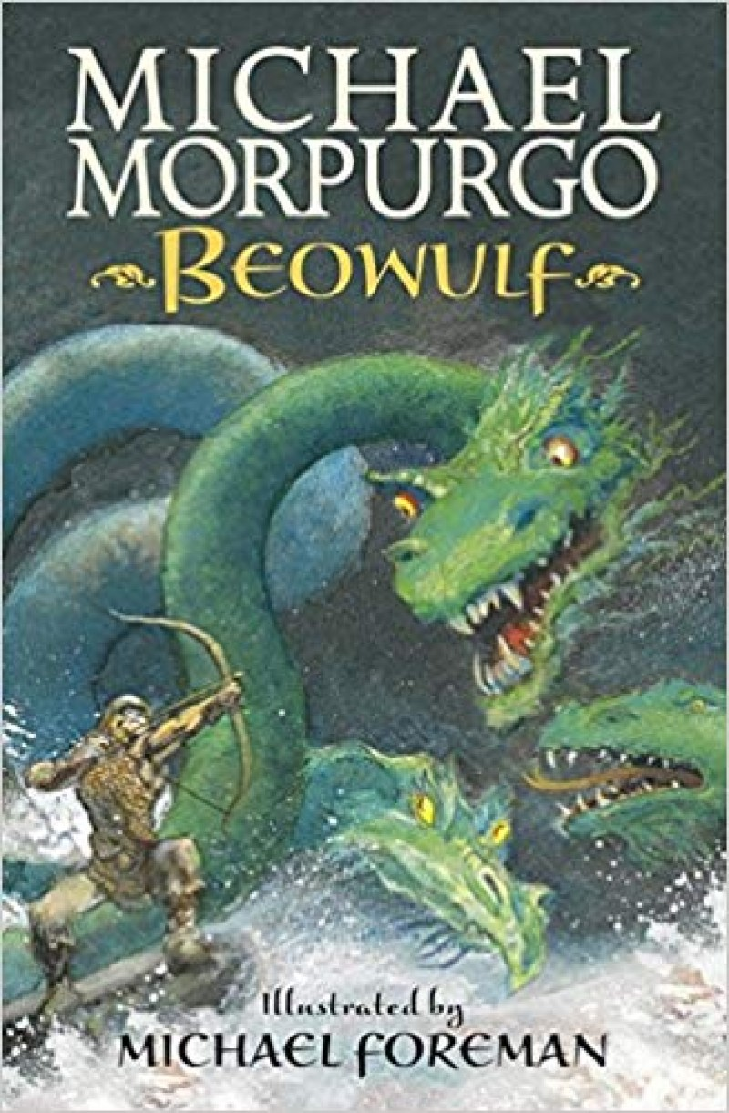
Maths | Decimals  In this unit children will:  add and subtract decimals with the same number of decimal places.  Multiply decimals by 10, 100 and 1000.  Divide decimals by 10, 100 and 1000.  Measurement  In this unit children will:  convert between different units of metric measure (for example, kilometre and metre; centimetre and metre; centimetre and millimetre; gram and kilogram; litre and millilitre).  understand and use approximate equivalences between metric units and common imperial units such as inches, pounds and pints.  solve problems involving converting between units of time .  use all four operations to solve problems involving measure [for example, length, mass, volume, money] using decimal notation, including scaling.  estimate volume.  Geometry  - know angles are measured in degrees: estimate and compare acute, obtuse and reflex angles  - draw given angles, and measure them in degrees (°)  - use the properties of rectangles to deduce related facts and find missing lengths and angles  - angles at a point and one whole turn (total 360°)  - angles at a point on a straight line and 1/2 a turn (total 180°)  - identify, describe and represent the position of a shape following a reflection or translation, using the appropriate language, and know that the shape has not changed | 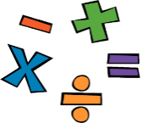
Science | Working Scientifically  Children will:  - Plan different types of scientific enquiries to answer questions, including recognising and controlling variables where necessary  - Use test results to make predictions to set up further comparative and fair tests  - Report and present findings from enquiries, including conclusions, causal relationships and explanations of and a degree of trust in results, in oral and written forms such as displays and other presentations  - Identify scientific evidence that has been used to support or refute ideas or arguments  Animals, including humans  Children will:  - Create a timeline to indicate stages of growth in humans.  Living things and their habitats  Children will:  - know the life cycle of different living things, e.g. mammal, amphibian, insect and bird.  - know the differences between different life cycles.  - know the process of reproduction in plants.  - know the process of reproduction in animals. |   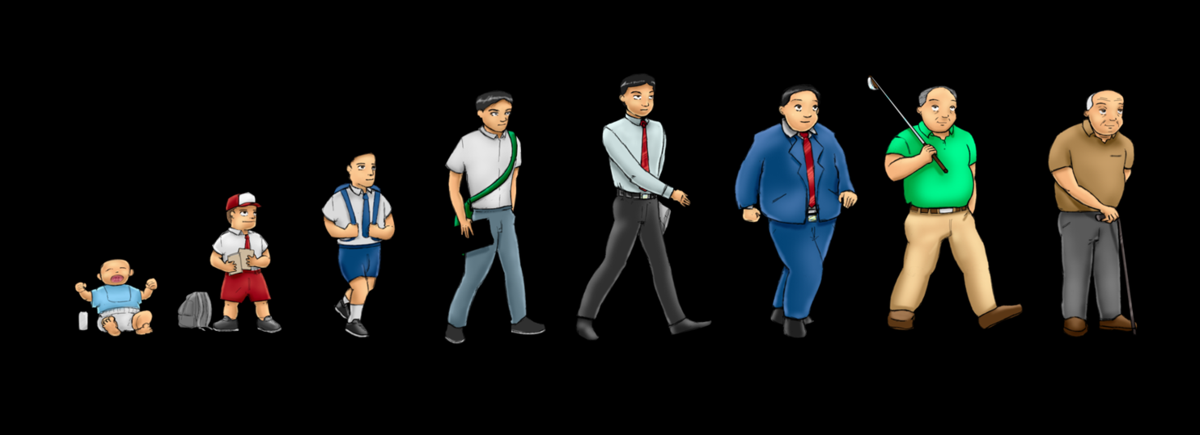  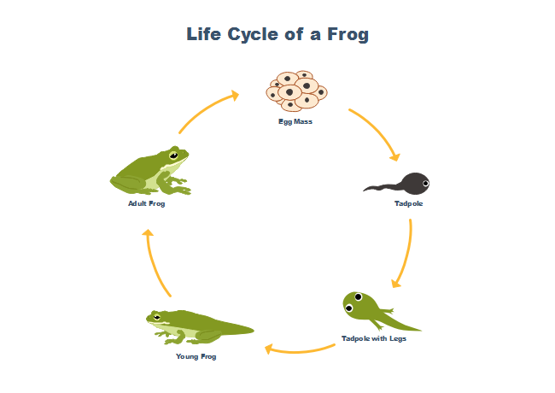
History | The Vikings  Children will:  - Refine lines of enquiry as appropriate  - Describe the characteristic features of the past, including ideas, beliefs, attitudes and experiences of men, women and children  - Use sources of evidence to deduce information about the past.  - Know that the Anglo Saxons and Vikings were often in conflict.  - Use a timeline to show when the Vikings raids started.  - Know why the Vikings often overpowered the Anglo Saxons  - Show on a map where the Vikings came from and where they invaded our country.  - Know that many Vikings came to our country as peaceful farmers. | 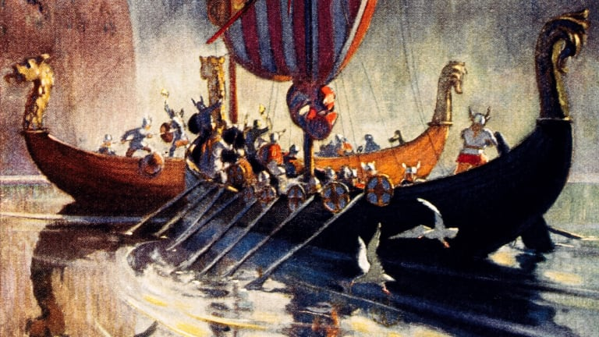
Geography | Deserts in North America  Children will:  Know what is meant by biomes and what the features of a specific biome are.  - Know how to use graphs to record features such as temperature or rainfall across the world.  - Know the names of and locate some of the world’s deserts using an atlas. | 
Music | - Freedom to improvise  - Battle of the Bands | 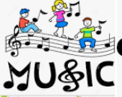
Computing | Using Purple Mash, pupils will learn to;  Word Processing  To format text in a new Word document and then save it.  To learn how to edit text and apply more advanced formatting.  To learn how to adjust the layout of a Word document.  To learn how to insert and format images in Word.  To use tables in Word to organise information.  To combine Word skills to create and review a factsheet  Concept Maps  To create a concept map.  To understand how a concept map can be used to retell stories and information  To create a collaborative concept map and present this to an audience. | 
PE | During the Summer term Year 5 will be going swimming.  Athletics  Children will develop their technique when: sprinting, jumping (long/high/triple), throwing (javelin & discus), hurdles and relay.  Invasion Games  Children will begin to learn activity specific skills and activity specific tactics (counter attack, man to man marking, zonal marking, high press, long ball). | 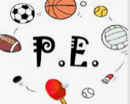
Art | Sustainable Art  Children will:  Experiment with media to create emotion in art.  Use the grid method to transfer an image.  Consider the sustainability of art and design.  Can make links between their own and other artists’ work.  Use sketchbooks to revisit and review ideas. | 
Design and Technology | Complex Electrical Systems  Children will:  - I come up with a range of ideas after collecting information from a range of sources.  - use a range of tools and equipment competently.  - suggest alternative plans: outlining the positive features and draw backs.  - explain how a product will appeal to a specific audience.  - evaluate appearance and function against original criteria. | 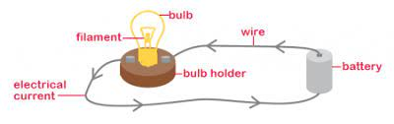
PSHE | TEN:TEN  Children will:  - Physically becoming an adult is a natural phase of life.  - Lots of changes will happen during puberty and sometimes it might feel confusing, but it is all part of God’s great plan and the results will be worth it!  - Pressure comes in different forms, and what those different forms are;  - There are strategies that they can adopt to resist pressure.  - Understand what consent and bodily autonomy means;  - Discuss and reflect on different scenarios in which it is right to say ‘no’.  - Learn about how thoughts and feelings impact on actions, and develop strategies that will positively impact their actions;  - To recognise that their increasing independence brings increased responsibility to keep themselves and others safe.  - How to use technology safely.  - That just as what we eat can make us healthy or make us ill, so what we watch, hear, say or do can be good or bad for us and others.  - Understand the effect that a range of substances including drugs, tobacco and alcohol can have on the body.  - Learn how to make good choices about substances that will have a positive impact on their health.  - Know that our bodies are created by God, so we should take care of them and be careful about what we consume.  - The recovery position can be used when a person is unconscious but breathing.  - DR ABC is a primary survey to find out how to treat life-threatening conditions in order of importance.  We will also continue the Mind Up curriculum learning how to understand different perspectives, expressing gratitude and taking mindful action in the world. |   

