Curriculum Information – Year 4 – Summer Term

English  Class Texts  Reading  Writing | Escape from Pompeii  Narrative  In Year 4 children will understand what they read, in books they can read independently, by  - checking that the text makes sense them  - discussing their understanding and explaining the meaning of words in context  - drawing inferences such as inferring characters’ feelings, thoughts and motives from their actions and justifying their inferences with evidence.  - making predictions based on text and from knowledge of other books  - asking questions to ensure understanding of a text  - identify the main ideas from more than one paragraphs in a text and summarise these  - identifying how language, structure and presentation contribute to meaning  Children in Year 4 will:  - plan their writing using talk for writing to understand and learn from its structure  - compose and rehearse sentences orally  - organise paragraphs around a theme  - use simple organisational devices such as headings and sub-headings  - evaluate and edit their own and others writing  - make improvement by proposing changes to grammar and vocabulary to improve consistency  - proof read their writing for spelling and punctuation errors. | 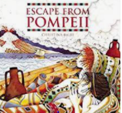  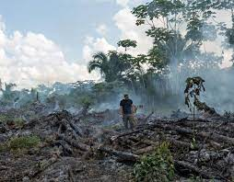
Maths | The children will learn about:  Decimals  - Recognise and write decimal equivalents of any number of tenths or hundredths.  - Solve simple measure and money problems involving fractions and decimals to two decimal places.  - Find the effect of dividing a 1- or 2-digit number by 10 and 100, identifying the value of the digits in the answer as ones, tenths and hundredths.  - Count up and down in hundredths; recognise that hundredths arise when dividing an object by one hundred and dividing tenths by ten.  Money  - Estimate, compare and calculate different measures, including money in pounds and pence.  - Solve simple measure and money problems involving fractions and decimals to two decimal places  Time  - estimate, compare and calculate different measures, including money in pounds and pence  - convert between different units of measure [for example, kilometre to metre; hour to minute]  - solve simple measure and money problems involving fractions and decimals to two decimal places  Statistics  - convert between different units of measure [for example, kilometre to metre; hour to minute]  - interpret and present discrete and continuous data using appropriate graphical methods, including bar charts and time graphs  - solve comparison, sum and difference problems using information presented in bar charts, pictograms, tables and other graphs  - identify acute and obtuse angles and compare and order angles up to two right angles by size  - compare and classify geometric shapes, including quadrilaterals and triangles, based on their properties and size  Geometry – Angles and 2D shapes  - compare and classify geometric shapes, including quadrilaterals and triangles, based on their properties and sizes  - identify lines of symmetry in 2-D shapes presented in different orientations  - complete a simple symmetric figure with respect to a specific line of symmetry  Geometry – Position and Direction  - complete a simple symmetric figure with respect to a specific line of symmetry  - describe positions on a 2-D grid as coordinates in the first quadrant  - plot specified points and draw sides to complete a given polygon  - describe movements between positions as translations of a given unit to the left/right and up/down | 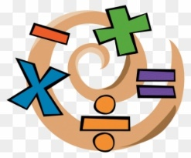  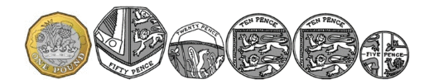  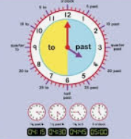
Science | Living Things and their habitats  - Children will: Group living things; classification keys.  - Change in environment can threaten life.  Animals Including Humans  Children will:  - Identify and name the parts of the human digestive system.  - Know the functions of the organs in the human digestive system.  - Identify and know the different types of teeth in humans.  - Know the functions of different human teeth.  - Use food chains to identify producers, predators and prey.  - Construct food chains to identify producers, predators and prey. | 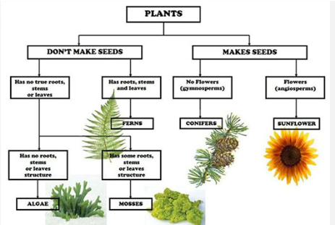  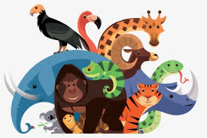  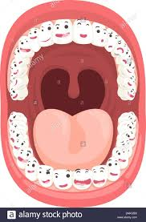
History | The Roman Empire  The children will:  - Know about at least three things that the Romans did for our country.  - Know why Romans needed to build forts in this country.  - Know that Rome was a very important place and many decisions were made there.  - Know about the lives of at least two Romans  - Summarise how Britain may have learnt from other countries and civilisations (historically and recently)  - Know the impact the Roman period had on world history. | 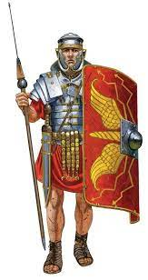
Geography | Rainforests  The children will:  - Label layers of a rainforest and know what deforestation is.  - Know where the Equator, Tropic of Cancer, Tropic of Capricorn and the Greenwich Meridian are on a world map.  - Know what is meant by the term ‘tropics’.  - Use maps and globes to locate the Equator, the Tropics of Cancer and Capricorn and the Greenwich Meridian.  - Know how to use an atlas, by using the index to find places. | 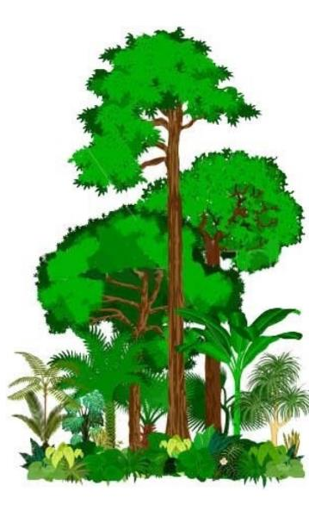
Music | Children will continue to learn a range of songs on the Ukulele that require pupils to learn a range of different chords. | 
Computing | Within the first computing unit of this term: composing beats pupils will  - Identify and discuss the main elements of music.  - Understand and experiment with rhythm and tempo.  - Create a melodic phrase using varied notes and pitch.  - Compose a piece of electronic music.  A further unit that pupils will study is Artificial intelligence, pupils will learn to:  - Understand what Artificial Intelligence is and some of the tasks it can carry out.  - learn to communicate effectively with AI tools by writing clear and precise prompts.​  - learn how to be a good digital citizen when using AI.​  - think about how AI might develop in the future.
PE | Athletics  In Year 4 children will:  - Develop their ability to hurdle effectively  - Develop their ability to Triple Jump effectively  - Develop their ability to throw the Javelin effectively  - Develop their ability to run the 400m effectively  - Develop their knowledge of how they can use their body to maximise performance  Additionally year 4 will be taught dance techniques by a specialist dance teacher. | 
Art | Pottery: The Shang Dynasty  The children will:  - Know how to use marks and lines to show texture in art  - Know how to sculpt clay & other mouldable materials  - Explain some of the features of art from historical periods.  - Use a sketchbook to record and improve ideas. | 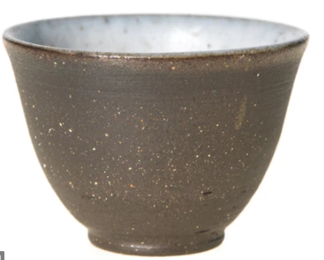
Design and Technology | Electrical Circuits  The children will:  - prove that their design meets some set criteria.  - design a product and make sure it looks attractive.  - follow a step by step plan choosing the right equipment and materials  - make a product which uses both electrical and mechanical components.  - choose material for both suitability and appearance.  - select the most appropriate tools and techniques for a given task. | 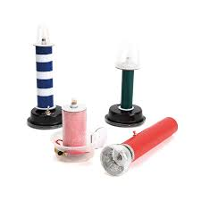
PSHE  RHE | Children in Year 4 will learn about:  - A Community of Love  - What is the Church?  - How should I love others?  - Water Safety  - Rail Safety  - World Rainforest Day  - Internet Safety  - Expressing Gratitude / Acts of Kindness  - Taking Mindful action in the world |   

