Curriculum Information – Year 3 –Summer Term

English  Class Texts  Guided  Reading texts  English:  Reading and Writing | Tutankhamun’s Tomb  Egyptian Poetry  Diary Entries  “The Fountain of Gold”, “The Snow Queen”, “All About Snow” – From the fairy tale anthology. “Escape from Black Mountain”.  In Year 3 children will:  - learn about the features of recounts, diary entries and poetry  - look at and discuss different models of writing taking into account purpose and audience  - plan writing by discussing and recording ideas  - suggest improvement through assessing their own writing and that of peers and through self-assessment  - make improvement by proposing changes to grammar and vocabulary to improve consistency. | 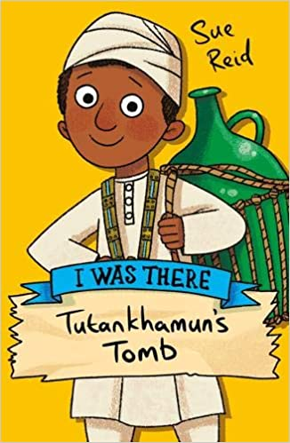
Maths | Fractions  Children will:  Find equivalent fractions, compare fractions, add and subtract fractions and solve word problems about fractions.  Time  Children will:  Learn about hours, days, months and years, estimate times, tell the time to the nearest minute, calculate start and end times and solve time problems.  Angles  Children will:  Learn about turns, know what a right angle is, draw parallel and perpendicular lines, recognise, describe and construct 3D shapes.  Money  Children will:  Learn how to record money in £ and pence. They will convert money, add and subtract amounts of money and solve problems that include finding change.  Statistics  Children will:  Present information in different ways including pictograms, bar charts and tables. They will answer questions based on information presented. | 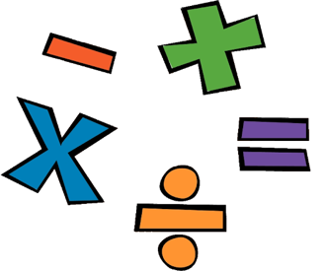  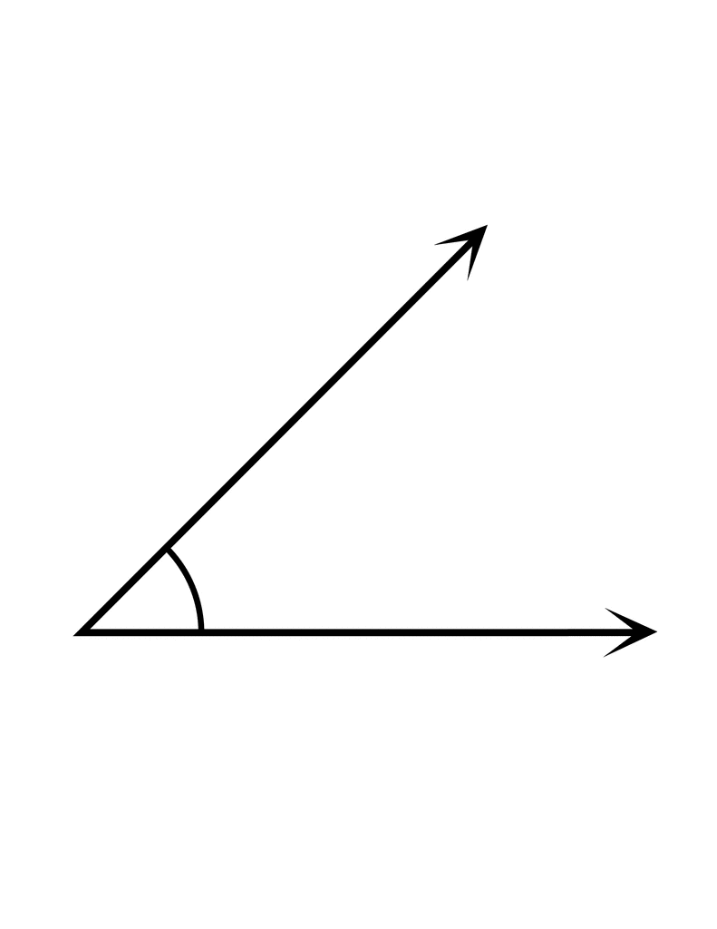
Science | Forces and magnets  Children will:  - describe how objects move on different surfaces.  - explain how objects attract and repel in relation to objects and other magnets.  - predict whether objects will be magnetic and carry out an enquiry to test this out.  - predict whether magnets will attract or repel and give a reason.  Light  Pupils will:  - know what dark is (the absence of light).  - know that light is needed in order to see.  - know that light is reflected from a surface.  - know and demonstrate how a shadow is formed.  - explore shadow size and explain the changes.  - know the danger of direct sunlight and describe how to keep protected. | 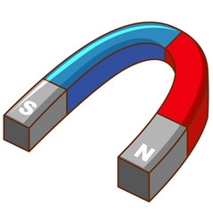  
History | Ancient Egypt  Pupils will:  - know the key features of Ancient Egypt.  - Place the period on a time line.  - Look at artefacts from this period  - know that there were advanced civilisations on earth 3000 years ago.  - Use a range of sources to find out about this period.  Planned trip to museum workshop | 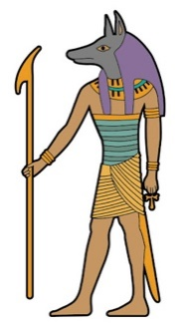
Geography | Rivers  Pupils will:  - Know and label the main features of a river.  - Know the name of and locate a number of the world’s longest rivers.  - Know why most cities are located by a river.  - Know the difference between the British Isles, Great Britain and the UK.  - Know and locate some of the main islands that surround the UK. | 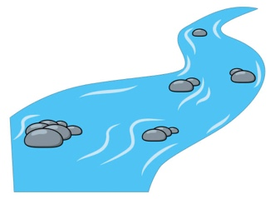
Music | Enjoying Improvisation  This project is about presenting a performance with an understanding of the songs they are singing and where they fit in the world and they can create their own band.  Opening night  This project is about presenting a performance with an understanding of the songs they are singing and where they fit in the world and they can create their own band. | 
Computing | Coding  Children will:  This unit builds on learning from previous coding units. Children will explore timers, the repeat command and the importance of nesting code. They will build up to using design documentation to code a program.  Presentations  Children will:  This unit introduces children to using Google Slides to create presentations. Children will explore features of the presentation software then create and present their own slideshow presentations.  Touch Typing  This unit introduces children to touch typing. Children learn correct posture, finger positioning and typing techniques to develop speed and accuracy, while understanding how these skills support safe and effective computer use. |   
PE | Dance  Children will be learning a range of dance routines with a dance teacher.  Athletics  Children will develop their ability to sprint, jump and throw. They will also begin to develop their ability to run middle to long distances.  Invasion games  Children will begin to learn the basic skills and techniques in Invasion Games (Passing, Receiving, and Dribbling, Shooting). | 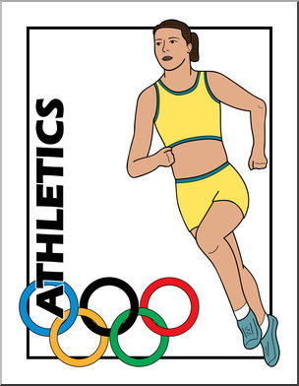
Art | Mixed media – digital art / graffiti - Banksy  Children will:  - Know how to use digital images and combine with other media.  - Know how to use IT to create art which includes their own work and that of others.  - Know how to compare the work of different artists.  - Use a sketchbook to record and revisit ideas. | 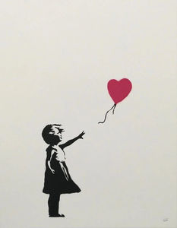
Design and Technology | Construction – lever and linkages  Children will:  - select the most appropriate tools and techniques for a given task.  - follow a step-by-step plan choosing the correct materials and tools.  - make a product which uses and mechanical components. | 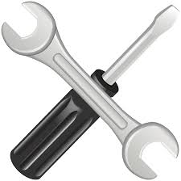
PSHE | In Year 3 children will:  - learn how to sharpen their senses through mindful movement  - learn that attitudes are important  - learn to be optimistic and appreciate happy experiences  - recognise that kindness and gratitude are important  - understand more about vocations and aspirations  - learn that we live in a community of love  - understand how the church can play a role in our lives  - understand more about the wider world in which we live | 

