Curriculum Information – Year 2 – Summer Term

Class Texts  English  Reading and Writing | The Sea Monster  Retell narrative The Sea Monster  Recount of our trip to Llanduno  Non chronological report about sea creatures  Poems about sea creatures  In Year 2 children will understand what they read, in books they can read independently, by  - Discussing the main events of the story.  - Discussing the characters in the story.  - Discussing the words that the author has used.  In year 2 children will use Talk for Writing to immerse themselves in a class text by  - Using story maps to internalise texts,  - Take part in drama to help them to understand texts  - Investigate text to use authorial devices.  - Retelling and innovating texts. | 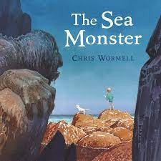
Maths | Statistics  Fractions  Position and direction  Time  Problem Solving | 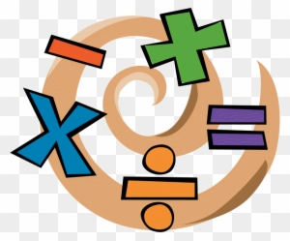
RE | Our Lady and Saint Benedict Catholic Academy has been chosen to work alongside the Diocese and take part in the Trial of the New RE Curriculum (RED). During this time, we will be working closely with the Diocese to ensure that the New RE Curriculum supports the Teaching and Learning of RE across all Year Groups and is progressive and meets the needs of all learners. The new RE curriculum is entitled 'To Know you More Clearly'. It consists of 6 branches which are spread out over the academic year. Due to the release of the branches the children will be learning about the Liturgical Year out of sequence. | 
Science | Plants  - observe and describe how seeds and bulbs grow into mature plants  - find out and describe how plants need water, light and a suitable temperature to grow and stay healthy  Living things and their habitats  - explore and compare the differences between things that are living, dead, and things that have never been alive  - describe how animals obtain their food from plants and other animals, using the idea of a simple food chain, and identify and name different sources of food | 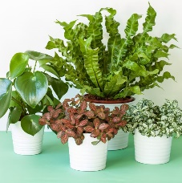  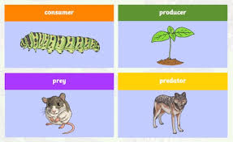
History | What was it like to be a soldier in the war?  1914: War began  1916: Battles at Verdun and  the Somme  1917: USA joined the war  1918: An armistice ended  the fighting  1919: Treaty of Versailles  The assassination of Archduke Franz Ferdinand, in the city of Sarajevo on 28 June 1914, started a chain of events that led to the first global war. Before the war started, many countries across Europe had agreed to help their allies (friends) if they were invaded. These treaties meant that countries across Europe were forced to enter the war. Great Britain, for example, only declared war against Germany after Belgium had been invaded by the German army. Soon after, most of Europe was at war.  At the start of war, many people volunteered to fight. They felt they were doing a patriotic duty and that the  war would be over in months. The war wasn't over quickly and soon everyone at home was working to support the war effort – this included women working in factories making weapons. | 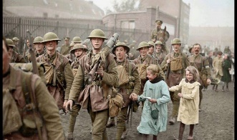  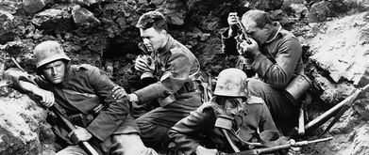
Geography | How is Florida different to Llandudno?  Know the main differences between a place in England and that of a small place in a non-European country. Scotland and Northern Ireland.  Identify the following physical features: mountain, hill, island, valley, ocean, coast, forest and beach.  Explain some of the advantages and disadvantages of living in a city, town or village.  Trip to Llandudno | 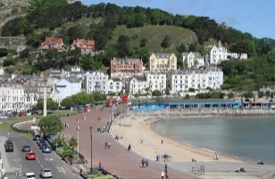  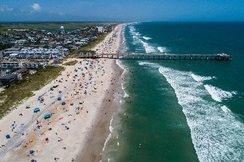
Music | Charanga Music  Exploring improvision  How does music make us happy?  Our big concert  How does music teach us about looking after our planet? | 
Computing | Presenting ideas  Understand that programs require precise instructions. Organise, retrieve and manipulate digital content.  Know how technology is used in school and outside of school.  Coding  Understand that algorithmns are used on digital devices.  Write a simple program and test it.  Predict what the outcome of a program will be.  Understand that programs require precise instructions.  Organise, retrieve and manipulate digital content.  Making music  Explore digital music creation through the use of the music tool, 2Sequence. Children learn about structuring a tune, creating music to represent a feeling and also making music to play in the background of a video clip. | 
PE | Athletics  Children will develop their sprinting technique, their throwing technique, the technique of a long jump, hurdles and how to run a relay race!  Multi skills  Children will continue to develop their existing skills of the ‘big 7’ (running, jumping, throwing, catching, balancing, striking, kicking) | 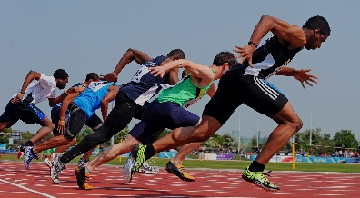
Art | What kind of art is made in Stoke-On-Trent?  Know how to make a clay pot  know how to join clay when making finger pots  know how to create a printed piece of art by pressing, rolling, rubbing and stamping  Emma Bridgewater – trip and factory tour | 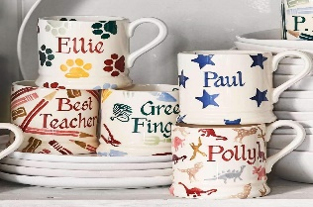
Design and Technology | Does fruit belong in a salad?  Think of an idea and plan what to do next  Describe the ingredients that I am using  Measure or weigh using measuring cups or electronic equipment.  Assemble and cook ingredients  Use the basic principles of a healthy and varied diet to prepare dishes  Understand where food comes from.  Trip to Slamwich | 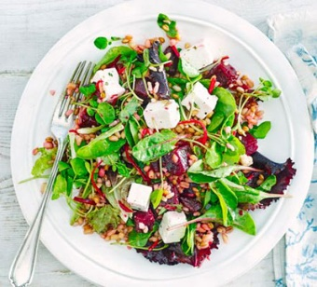
PSHE | In our PSHE sessions we will find out about:  Appreciating happy experiences  The cycle of life  Three in one  Who is my neighbour?  The communities we live in  Expressing gratitude.  Performing acts of kindness  Vocations – careers and aspirations  Money  Taking mindful action in the world  Transition | 

