Curriculum Information: Year 1 Summer Term

English  Class Texts  Reading and Writing | Narrative: - Lost & Found  Non-fiction: Polar Bears  In year 1 children will complete preparing for place value and punctuation.  In Year 1 children will understand what they read, in books they can read independently, by  - Discussing the main events of the story.  - Discussing the characters in the story.  - Discussing the words that the author has used.  In year 1 children will use Talk for Writing to immerse themselves in a class text by  - Using story maps to internalise texts,  - Take part in drama to help them to understand texts  - Investigate text to use authorial devices.  - Retelling and innovating texts. | 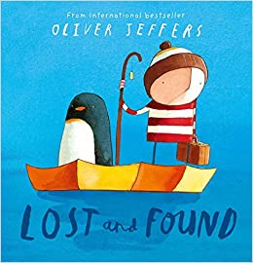
Maths | Multiplication and Division  - Children will develop their understanding of multiplication as repeated addition.  - They will understand the difference between equal and not equal groups.  - They will use their knowledge of skip counting in 2s, 5s and 10s.  - They will use concrete, pictorial and abstract representations, such as arrays, to find the total of multiple equal groups and doubles.  - Children will move on to grouping and sharing.  Fractions  - Children will learn how to find halves and quarters of both shapes and groups of objects.  - Children will be able to use strategies to find halves and quarters.  Position and Direction  - Children will learn how to describe rotations such as quarter, half, three-quarter and whole turns.  - They will use this knowledge to give and follow route instructions.  - Children will learn to describe the position of an object in relation to other objects, using the words ‘above’, ‘below’, ‘left’, ‘right’ and ‘between’.  Numbers to 100  - Children will develop their understanding of numbers to 100.  - They will begin by counting beyond 50 and noticing the counting patterns.  - They will use a 100 square and other pictorial representations.  - Children will count by counting the 10s first and then the 1s.  - They will position numbers on a number lie and use these to compare two 2-digit numbers.  - Children will find one more and one less than numbers to 100.  Money  - Children will learn to recognise coins and banknotes and their values.  - They will learn that the values of a coin or note depends on both the numerical value assigned to it and the unit (pounds or pence) that are involved.  Time  - Children will develop their ability to tell the time by reading an analogue clock or watch.  - They will estimate and compare durations.  - Carry out simple calculations involving time.  - They will develop their understanding of units of measurement of time (hours and minutes).  - They will use vocabulary to understand durations of time and ordering events in time. | 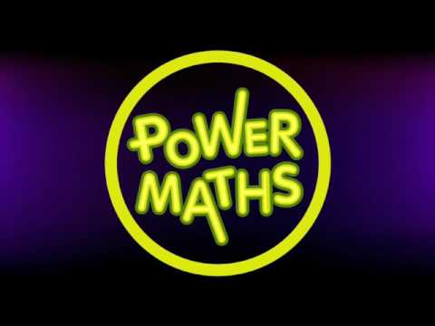
Science | Everyday Materials / Plants  - Identify and name a variety of common wild and garden plants, including deciduous and evergreen trees.  - Identify and describe the basic structure of a variety of common flowering plants, including trees.  Seasonal Change (Spring to Summer)  - Children will observe, measure and record the weather throughout the season.  - They will observe signs of spring and summer through nature and wildlife. | 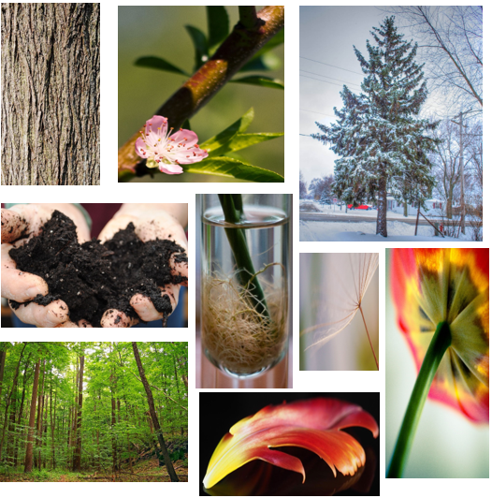
History | Who is the Lady with the lamp?  Children will learn to:  - Know a famous person from the past and explain why they are famous.  - Know what a number of older objects were used for.  - Spot old and new things in pictures.  - Know words and phrases like before after past present then and now.  - Know about many of the changes that have happened since I was born. | 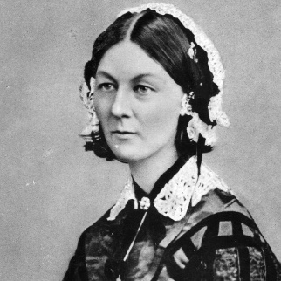
Geography | Geography: Polar Regions  Children will learn to:  - Know features of hot and cold places in the world and know what clothes to wear in these places.  - Know and recognise main weather symbols.  - Know where the equator, North Pole and South Pole are on a globe. | 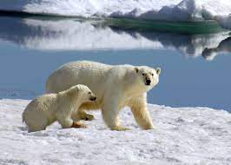
Music | Having Fun with Improvisation:  Improvising is fun! It’s an exciting activity where everyone is creating something new. It can be a melody or a rhythm.  Let’s Perform Together:  Singing, dancing and playing together is called ‘performing’. Performing together is great fun! Plan a concert together to celebrate all the songs you have learnt this year. |   
Computing | Technology Outside of School  In this unit the children will learn:  - To find and understand examples of where technology is used in the local community.  - To record examples of technology outside school.  Coding  In this unit the children will learn:  - To understand what coding means in computing.  - How to create unambiguous instructions like those required by a computer.  - To build one- and two-step instructions using the printable code cards.  - How to design a scene for a program.  - How to use code blocks to make the characters move automatically when the green Play button is clicked.  Making Beats  This unit introduces digital music. Children will use the tools 2Explore and 2Beat to make their own digital music | 
PE | Athletics & HRE ‘Exercise & our body’  In Summer the children in Y1 will start to learn how to improve their ability to run fast, jump high and throw far! (They’ll also start to learn their races ready for Sports Day!) | 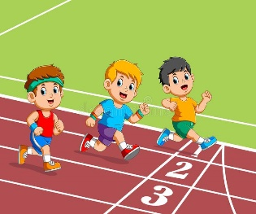
Art | Using materials  Children in Year 1 will learn:  - know how to use IT to create a picture  - know how to cut, roll & coil materials  - Describe what can be seen and give an opinion about the work of an artist. |   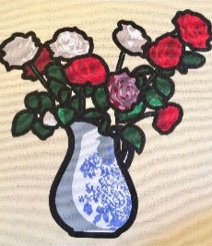
Design and Technology | Textiles  The children will learn how to:  - Design products that have a clear purpose and an intended user  - Tell someone about their ideas  - Join textiles using running stitch | 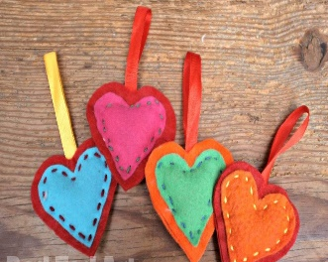
PSHE | TenTen  Created to Live in Community  - Created to Live in Community explores the children’s relationship with the wider world. Here we explore how human beings are relational by nature and are called to love others in the wider community through service, through dialogue and through working for the Common Good.  - Mind up – perspective taking. | 

